List

1. It is a heterogeneous collection of data
2. It is ordered collection.
3. It allows to access data by index, and hence random access is possible
4. It allows to store duplicate values.
5. It is mutable.
6. It is represented using []

|  |  |
| --- | --- |
| Lst.append(value) | It adds single value at the end of the list |
| Lst.extend(iterable) | It adds all values at the end from iterable one by one in the lst |
| Lst.insert(pos,value) | It will add the value at the given position, if position is out of bounds, then it will insert at the end |
| Lst.pop([pos]) | It will delete the data from last index position if the pos is not given, otherwise it deletes from the given position |
| Lst.remove(value) | It will delete the first occurrence of the given value from the list if found, otherwise it throws an exception |
| Del(lst[pos]) | It deletes the data from the given position |
| Lst.index(value,[start,end]) | It will give you the position of the first occurrence if found, otherwise it throws an exception |
| Lst.clear() | It removes all the data from the list, and keeps the list with 0 length |
| Lst.reverse() | It will reverse order of the list, but it changes the original list |
| Lst.sort() | It will sort the list only if the list is homogenous, it changes the original list |
| Lst.copy() | It is used to create a shallow copy of the list |

Copy function in the list creates a shallow copy

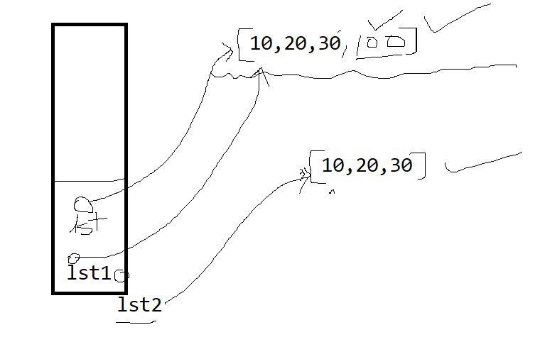

lst=[12,23,34]

lst1=lst

lst.append(100)

print(lst)

print(lst1)

lst2=lst.copy()

lst.append(200)

print(lst,lst1)

print(lst2)

|  |  |
| --- | --- |
| Zip(lst,lst1,lst2,lst3) | It is used to read data from multiple lists simulteneouly |
|  |  |
|  |  |
|  |  |

